

**Student Assessment Submission and Declaration**

When submitting evidence for assessment, each student must sign a declaration confirming that the work is their own.

|  |  |  |  |
| --- | --- | --- | --- |
| Student name: Thet Phoo Wai | | Assessor name: Khin Ma Ma Cho | |
| Issue date: 3/ 24/ 2023 | Submission date: 3/ 30/ 2023 | | Submitted on: 3/ 30/ 2023 |
| Programme: Pearson BTEC Level 5 HND in Application Development | | | |
| Unit 54: Prototyping | | | |
| Developing a UI/UX Design Prototype for an Ecommerce Website | | | |

**Student Declaration**

|  |
| --- |
| **Student declaration**  I certify that the assignment submission is entirely my own work and I fully understand the consequences of plagiarism. I understand that making a false declaration is a form of malpractice.  Student signature: Julia Date: **3/ 30/ 23** |

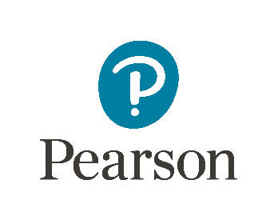

Pearson Education 2018

Higher Education Qualifications

Table of Contents

Introduction 3

Relevance of Various Tools for Dynamic End-User and Functionality Testing Needs: 5

End-User Testing Requirements 5

Table: Prototyping Types and Tools Comparison 7

Axure Installation of the Most Recent Version: 8

5 Features Used in Axure for This Project: 9

Personas: 16

Prototyping Plan: 17

Analyzing the impact of prototyping techniques on the software development lifecycle: 19

Design and Development: 19

Examining User Feedbacks: 20

UX KPI Calculations of the Boutiqa Prototype: 31

Evaluation of Test Results 33

New Iteration Indicating 34

# Introduction

The way people shop is changing as a result of the e-commerce industry's rapid growth. Businesses are putting more effort into creating user-friendly e-commerce websites in response to the growing demand for online buying in order to offer a seamless shopping experience. We are creating a prototype for the "Boutiqa" e-commerce website in this project, which sells apparel and accessories.

Our objective is to provide a platform that is simple to use and satisfies the needs of the target market while offering a simple and hassle-free buying experience. To guarantee that the final product satisfies the end-users' expectations, the project calls for numerous prototype iterations.

We will create several prototypes using the relevant tools, such Axure, and conduct end-user trials to gather feedback and enhance the prototype. The development process will be guided by the end users' comments, which will also help us improve the prototype to achieve the desired outcomes.

To make sure we have achieved the project's goals, we will assess the final prototype version, test findings, and compare them to the original objectives and plan at the project's conclusion. The project's goal is to create an effective and user-friendly online store that offers users a smooth purchasing experience.

Requirements for Specialized Prototyping Functionality and End-User Testing

In order for designers and developers to assess a product's performance, functionality, and usability, prototyping is a crucial process in the software development process. In order to detect and address any flaws early on in the process, this is a crucial phase in the development of any good or service. There are different prototype techniques, and each has particular needs in terms of functionality and end-user testing. We'll discuss a few different prototype techniques, their uses, and the criteria for user testing in this session.

Low-Fidelity Prototyping:

Low-fidelity prototyping is a quick and economical way to test early-stage ideas and concepts. It entails producing rough sketches, wireframes, or paper prototypes that can be used to test usability, user flows, and interaction design. This kind of prototype is excellent for checking an application's fundamental operation and locating any potential usability problems. End users can test low-fidelity prototypes in-person or remotely.

Medium-fidelity Prototyping:

With extra functionality features including navigation menus, buttons, and simple animations, medium-fidelity prototypes are more advanced than low-fidelity prototypes. The purpose of these prototypes is to offer a more accurate illustration of the design and functionality of the final product. They focus on giving the end-user a more interactive experience and have more complex functionality requirements than low-fidelity prototypes. With medium-fidelity prototypes, end-user testing should concentrate on assessing the product's usability, locating any potential functional problems, and testing the fundamental features.

High-fidelity Prototyping:

The most sophisticated type of prototyping is high-fidelity prototyping, which includes advanced functionality elements including interactive menus, animations, and dynamic content. With cutting-edge technology and a refined design, these prototypes are meant to be a faithful depiction of the finished product. They have stringent functionality requirements and put a strong emphasis on giving the end user a seamless experience. High-fidelity prototype end-user testing ought to concentrate on assessing the product's usability, finding any potential functional problems, and testing its advanced features.

Functional Prototyping:

Making a working prototype that closely mimics the finished product is known as functional prototyping. This kind of prototype is excellent for evaluating an application's performance and usefulness. Functional prototypes can be evaluated with end users in person, online, or in usability testing facilities.

Visual Prototyping:

By using visual prototyping, an application's branding and visual design are highlighted in the prototype. Testing an application's aesthetic appeal and branding is made easy with this kind of prototyping. Visual prototypes can be put to the test with real people through in-person sessions, in usability testing facilities, or remotely.

Multiple techniques can be used for prototyping, including:

* Wireframing: A website or application's layout, user flow, and structure are shown visually in wireframes. Before any development work starts, the user experience of a product or service is mapped out using wireframes to spot any possible problems and make any necessary adjustments.
* Mockups: Because they provide a visual depiction of the good or service, mockups are more detailed than wireframes. Mockups are utilized to see how the product or service will appear to users and how they will interact with it.
* Paper Prototypes: Paper prototypes are basic drawings of the product's design and characteristics. These quick and inexpensive prototypes let designers test a product's functioning and layout without spending a lot of time or money. Their modest functionality demands center on giving a visual depiction of the product's layout and essential features.

# Relevance of Various Tools for Dynamic End-User and Functionality Testing Needs:

There are many different prototype tools on the market, and each has advantages and disadvantages. The particular end-user testing needs, and functionality testing requirements determine the prototyping tool to be used. Popular prototyping tools include:

Axure:

Axure is an extremely popular prototyping tool that's frequently used to make intricate, high-fidelity prototypes. It enables designers to produce interactive wireframes, user flows, and animations. Axure is effective for testing intricate user flows and interactions.

Figma:

Figma is a popular cloud-based design tool for group prototyping. With cutting-edge collaborative features, it enables designers to produce high-fidelity prototypes. Remote user testing and collaborative design process evaluation are both appropriate uses for Figma.

Adobe XD:

Interactive prototypes are frequently made using the well-liked prototyping program Adobe XD. Wireframes, user flows, and animations can all be made by designers. For testing fundamental functionality and interactions, Adobe XD is appropriate.

InVision Studio:

The popular prototyping program InVision Studio is frequently used to create interactive prototypes. Design professionals can use it to make clickable prototypes, user flows, and animations. It is useful for testing intricate user flows and interactions.

# End-User Testing Requirements

End-user testing is a crucial stage in the development process since it enables the developer and designers to find any problems with the good or service before it is made available to the general public. End users should be given a list of prerequisites they must fulfill in order for the good or service to satisfy their demands. An end-user testing requirement list should include the following specifications:

* Performance: It should be requested that end users test the responsiveness and performance of the good or service. Testing for speed or sluggish loading times is part of this.
* Usability: It is important to ask customers if a product or service is simple to use and understand. Testing the user interface and user experience is part of this.
* Security: Customers should be requested to test the product's or service's security. Testing for any flaws or potential exploits falls under this category.
* Compatibility: To ensure compatibility, end customers should be asked to test the good or service on various hardware and software platforms.

Understanding the exact needs for end-user testing is essential to choose the best prototyping technique. The appropriate prototyping technique is listed in the table below along with a summary of the various end-user testing needs.

|  |  |
| --- | --- |
| **End-User Testing Requirement** | **Suitable Prototyping Method** |
| Functionality Testing | Low-fidelity Prototyping |
| Usability Testing | Medium-fidelity Prototyping |
| User Acceptance Testing | High-fidelity Prototyping |
| Concept and Layout Testing | High-fidelity Prototyping |
| A / B Testing | High-fidelity Prototyping |

The requirements for the end-user testing will determine the methodology and prototyping tool to utilize. The effectiveness of different tools for various functionality and end-user testing criteria is shown in the following table:

|  |  |
| --- | --- |
| **End-User and Functionality Testing Requirements** | **Suitable Tools** |
| Early-stage testing and gathering feedbacks | Pen and paper, Balsamiq, Sketch |
| User experience testing and usability testing | Axure, Adobe XD |
| Technical testing and identifying bugs | Html, CSS, and JavaScript |

# Table: Prototyping Types and Tools Comparison

|  |  |  |  |  |
| --- | --- | --- | --- | --- |
| **Types of Prototyping** | **Goals** | **Functionality** | **End-User Testing Methodology** | **Tools** |
| Paper Prototypes | To test the design and navigation, as well as to get user feedback | User interface sketches or diagrams that have been hand-drawn | End users evaluate sketches and offer input on usability issues | Ink and paper |
| Low-fidelity Prototypes | Testing essential features and user processes, as well as gathering user feedback | Interactive wireframes that are simple | End users interact with the wireframes and give comments on the functionality, design, and usability | Figma, Mockplus, and Balsamiq |
| High-fidelity Prototypes | To evaluate complex features, animations, and user interfaces and to get user input | Mockups that are detailed and interactive | End users evaluate prototypes and offer comments on the designs, usability, and user experience | Sketch, Adobe XD, and Axure |
| End-user Testing Tools | To Evaluate User Experience and Get End-User Feedback | Range between basic questionnaire method and sophisticated usability testing technologies | Using evaluations, interviews, or testing sessions, end users provide feedback | Optimizing Workshop and user testing |

# Axure Installation of the Most Recent Version:

Go to the Axure website (www.axure.com) and click the “Download” button.

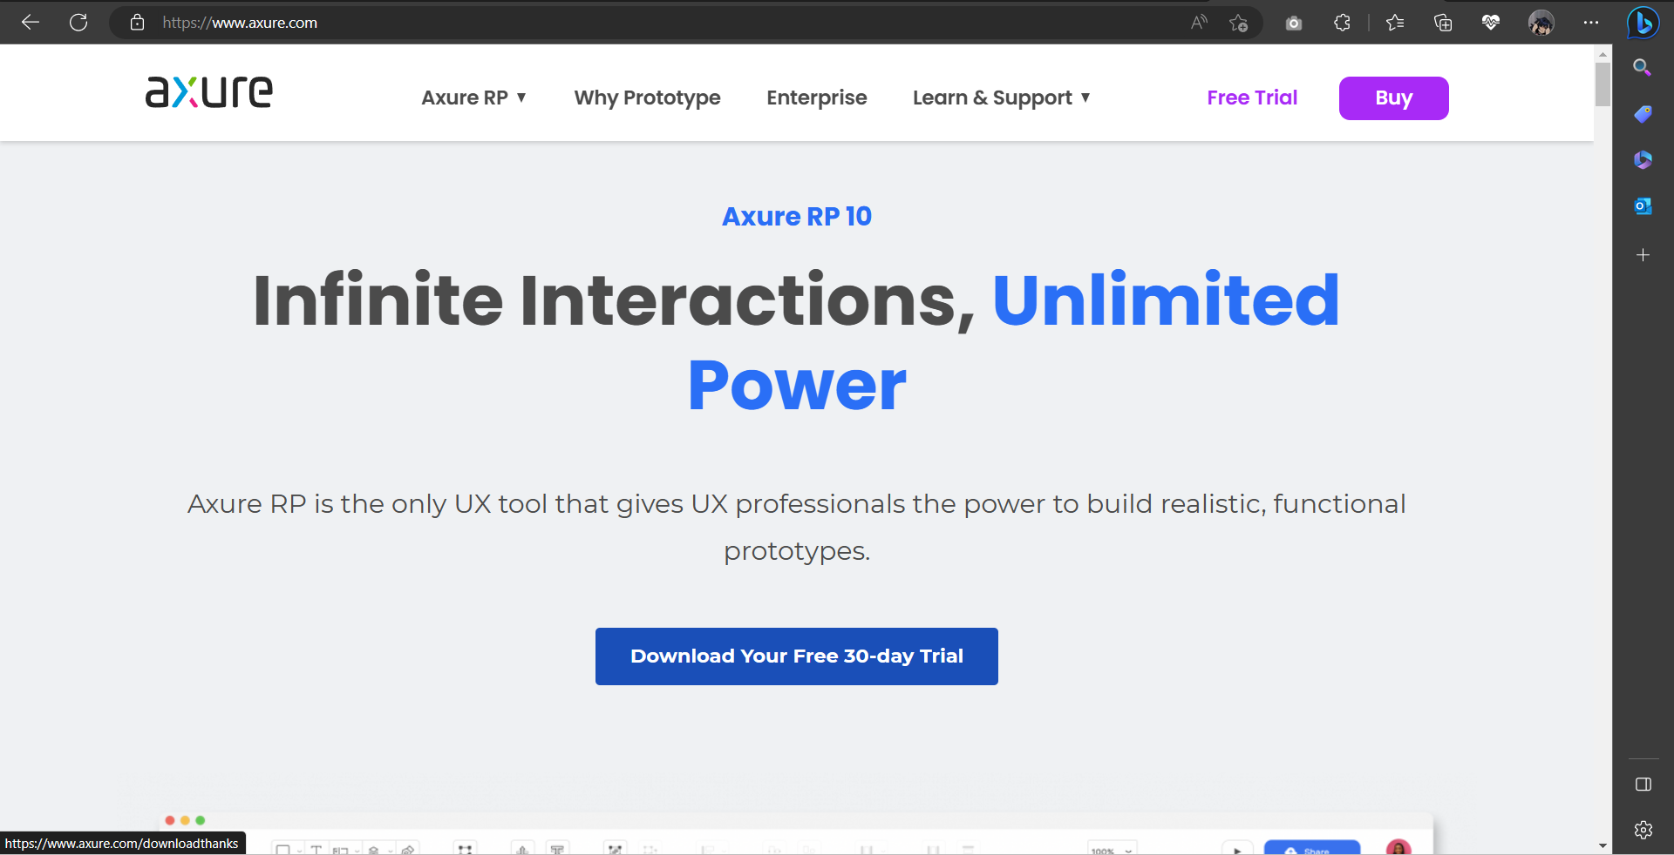

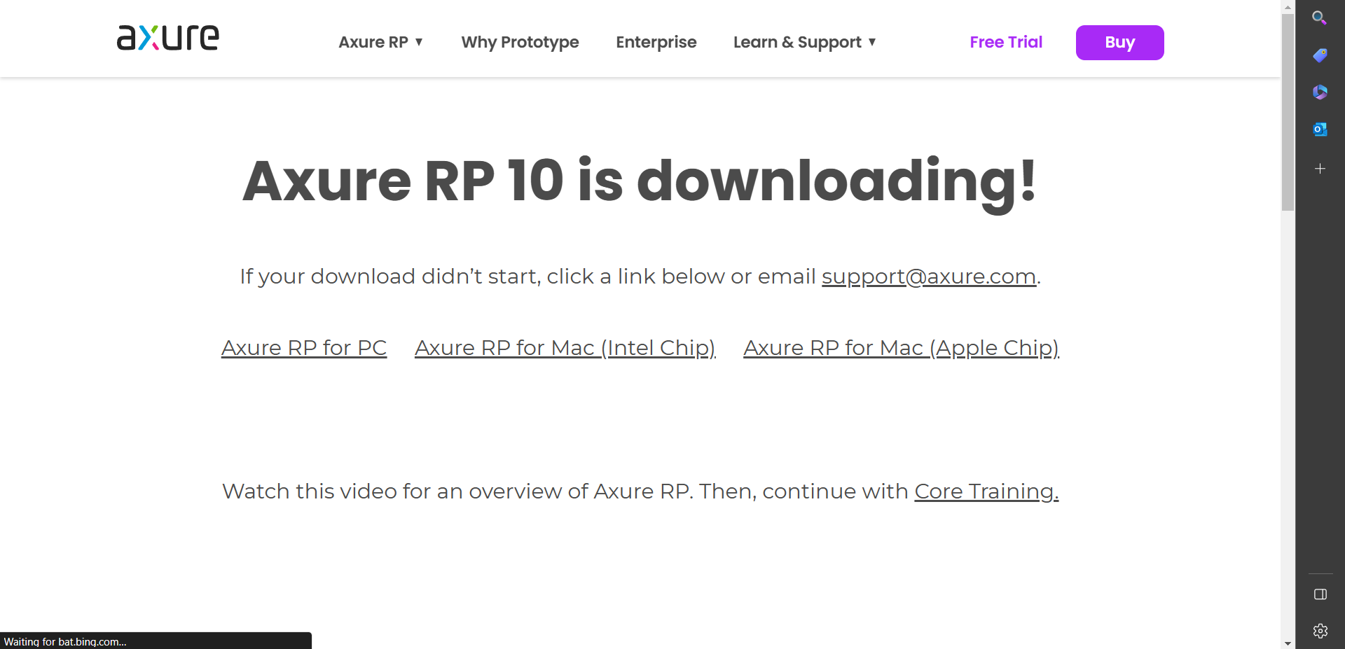

Once the installation is complete, launch Axure and you’re ready to start prototyping.

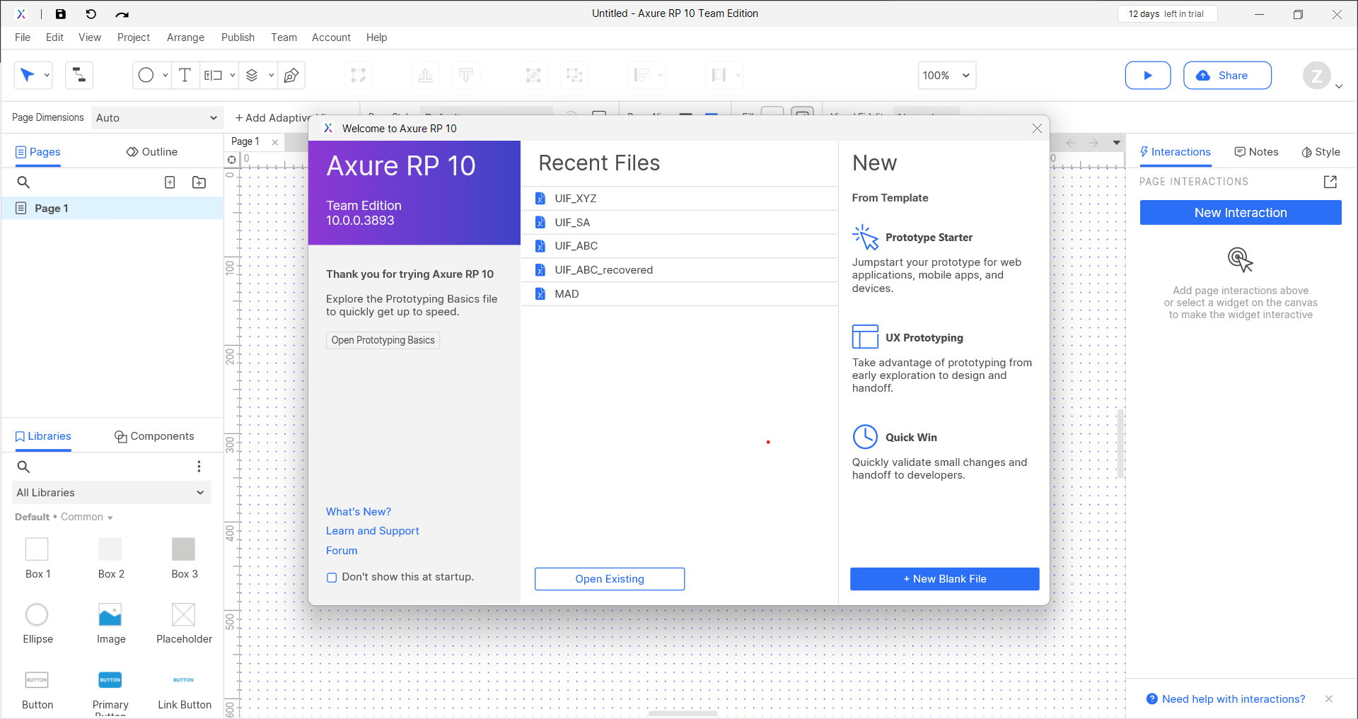

# 5 Features Used in Axure for This Project:

* The option to drag and drop widgets and elements

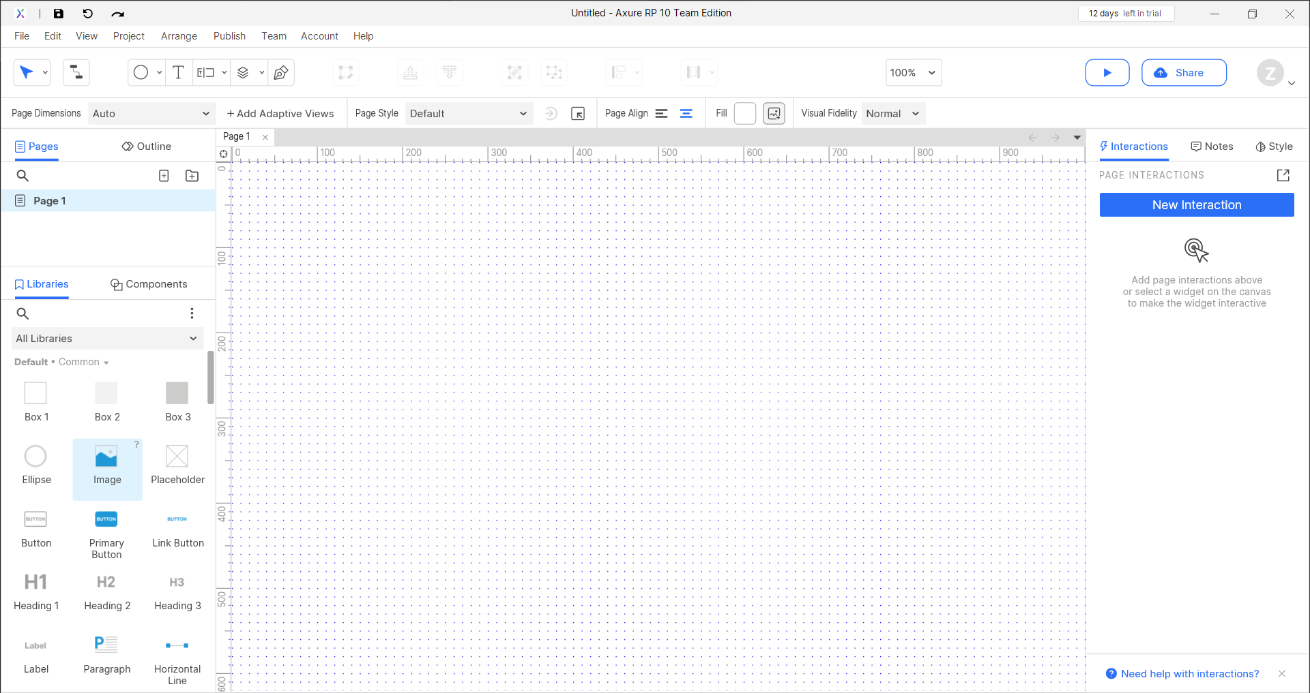

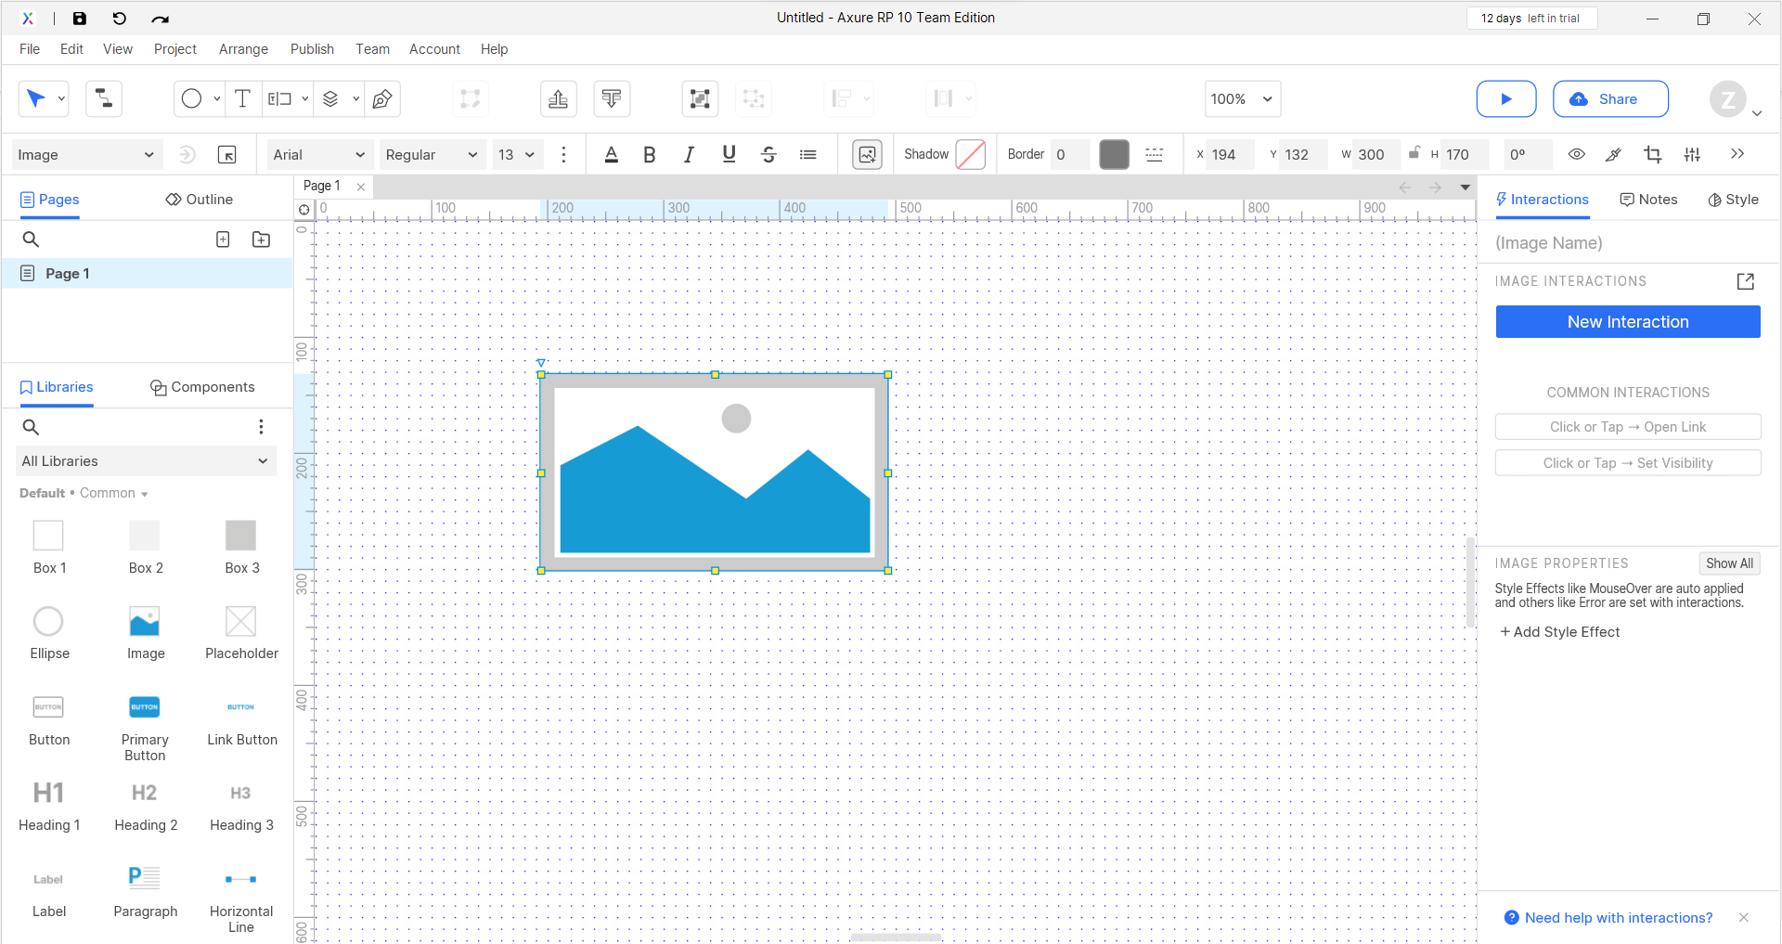

* Click the “Preview” button to view your prototype in the browser

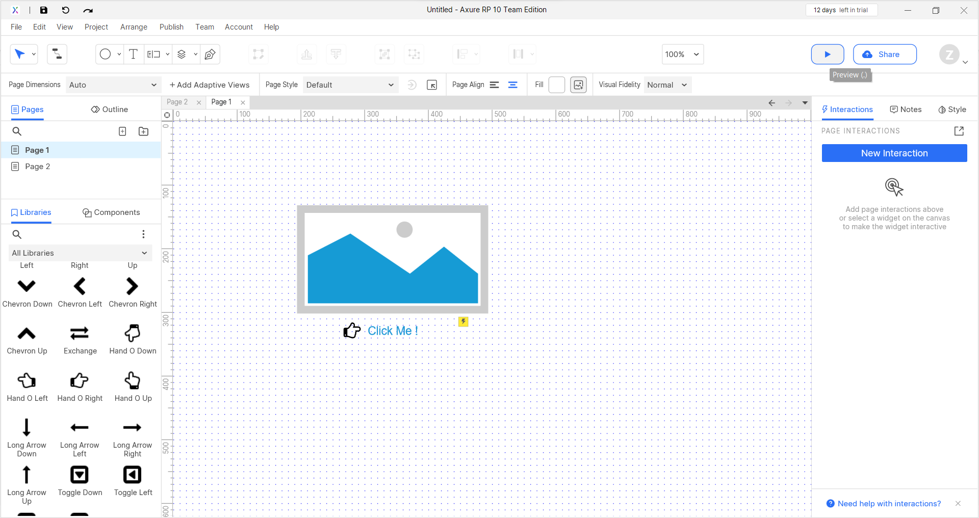

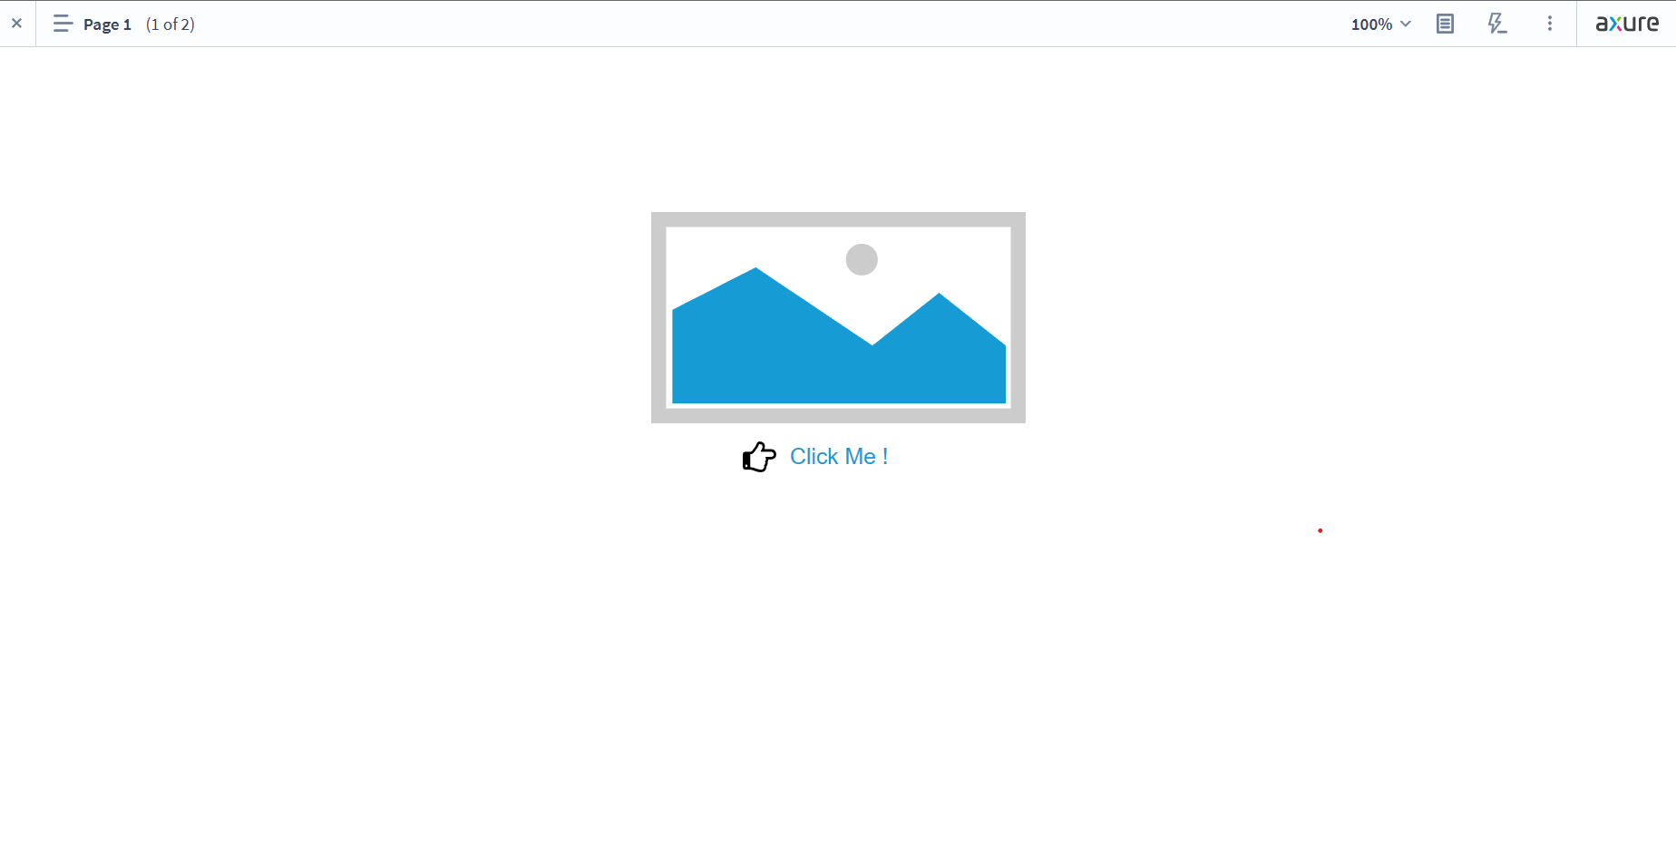

* Interactive navigation and page linking

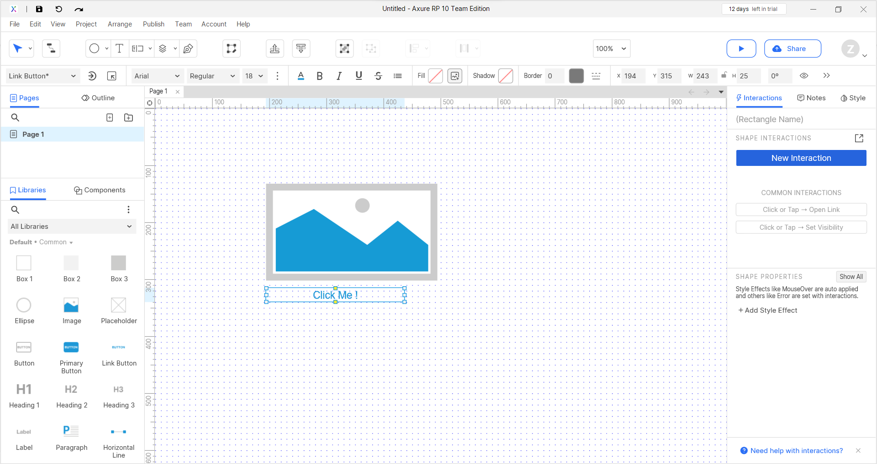

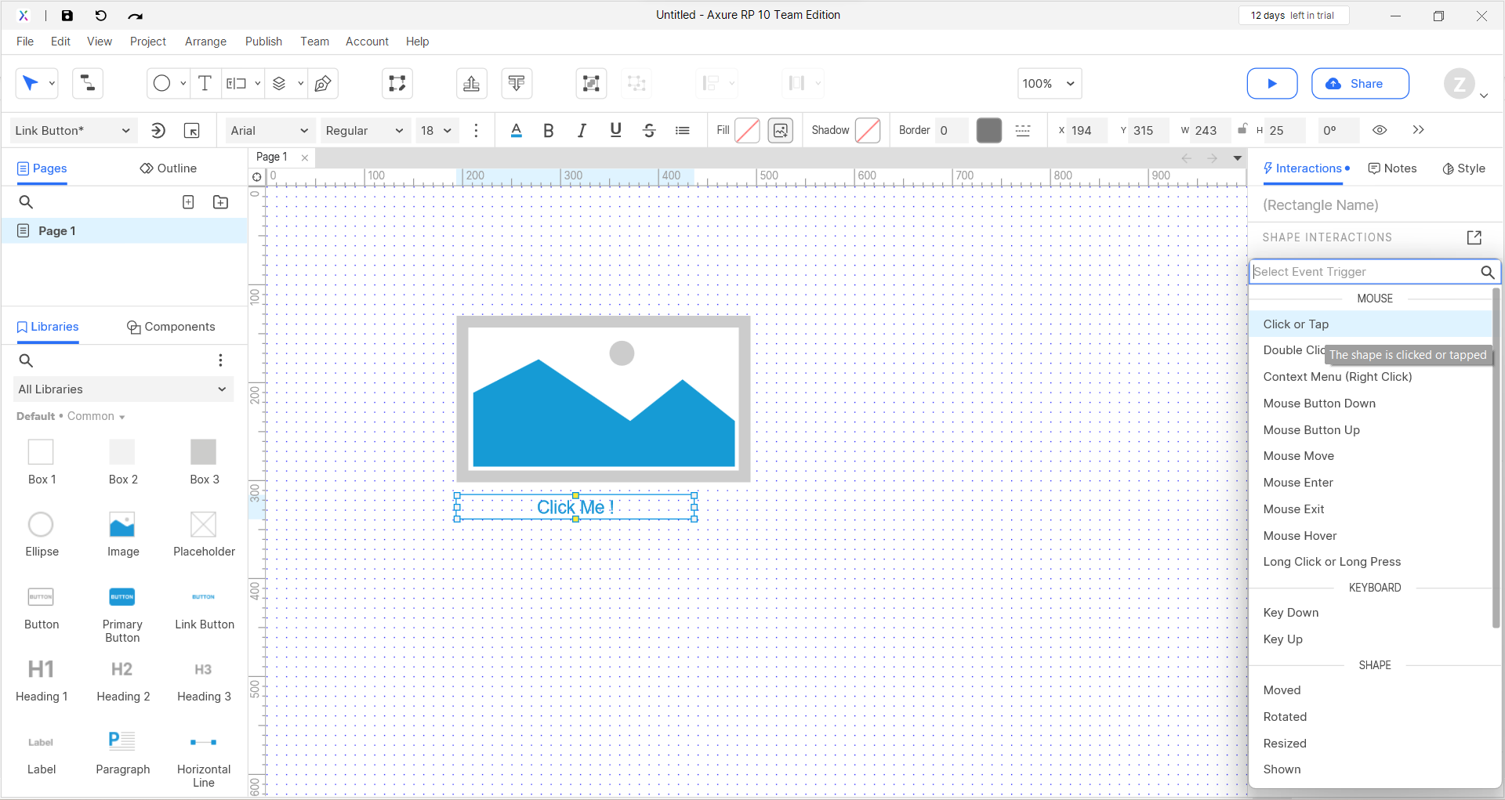

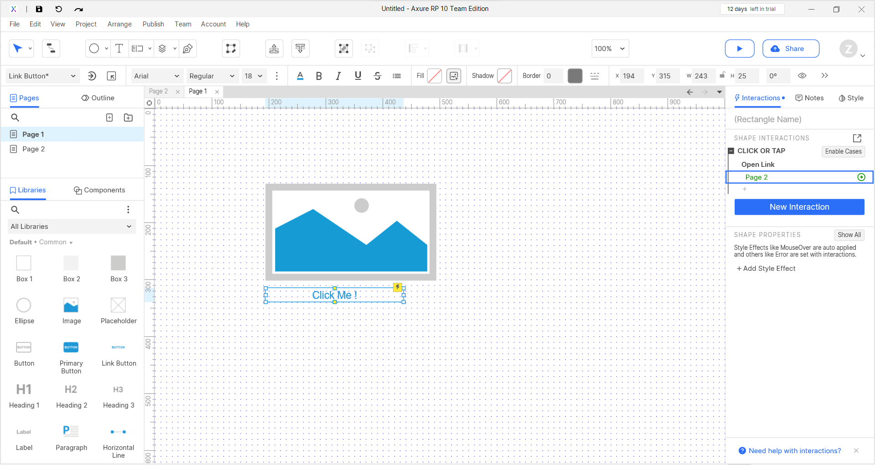

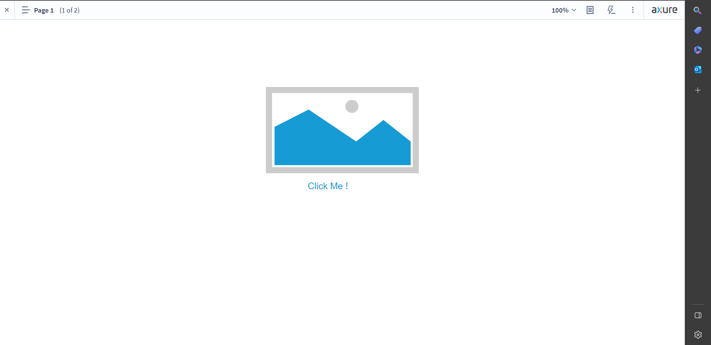

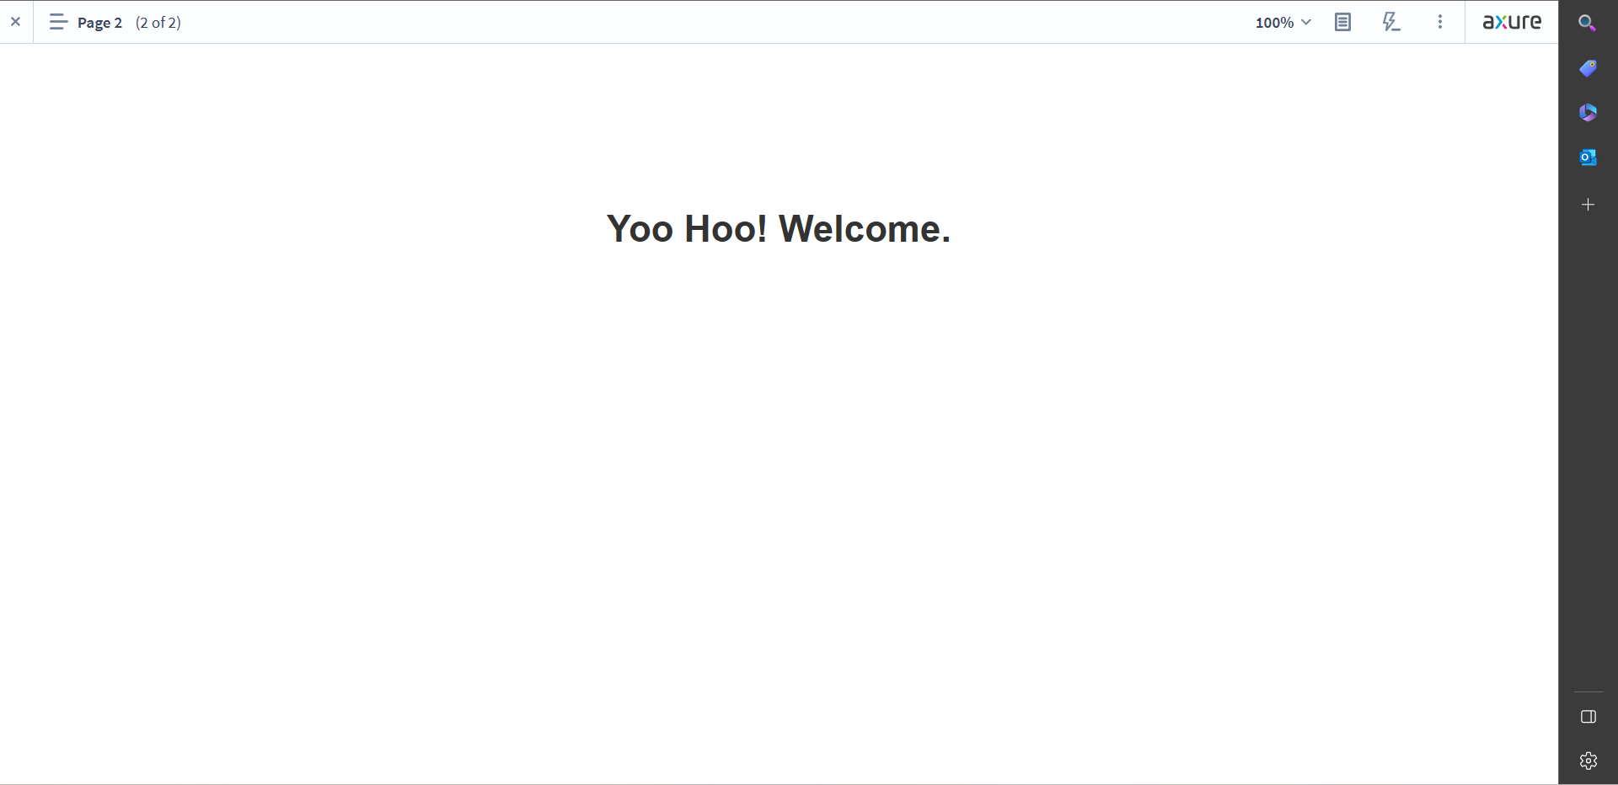

* Notes and annotations for feedback and team collaboration

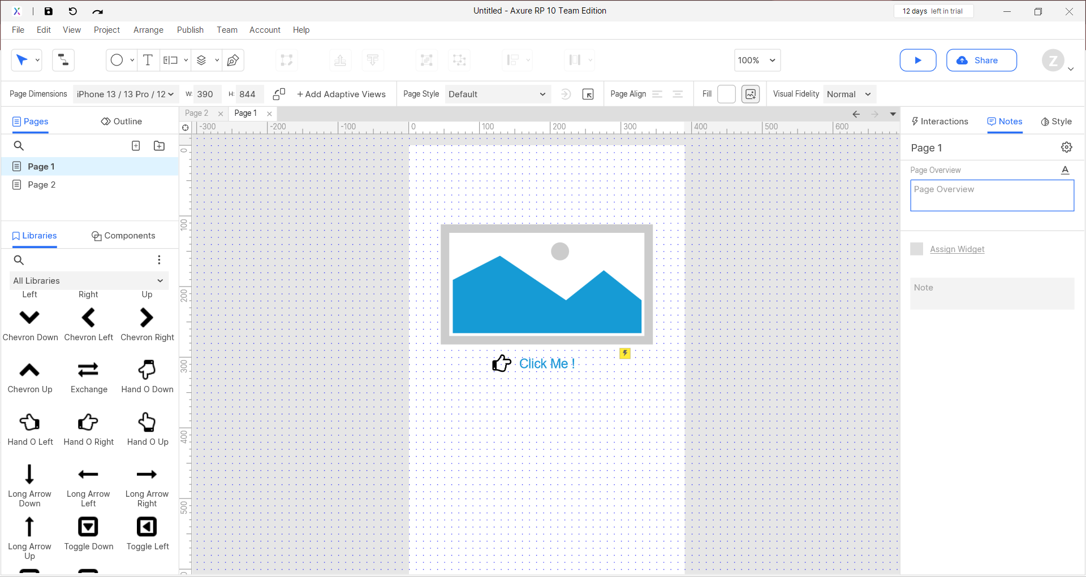

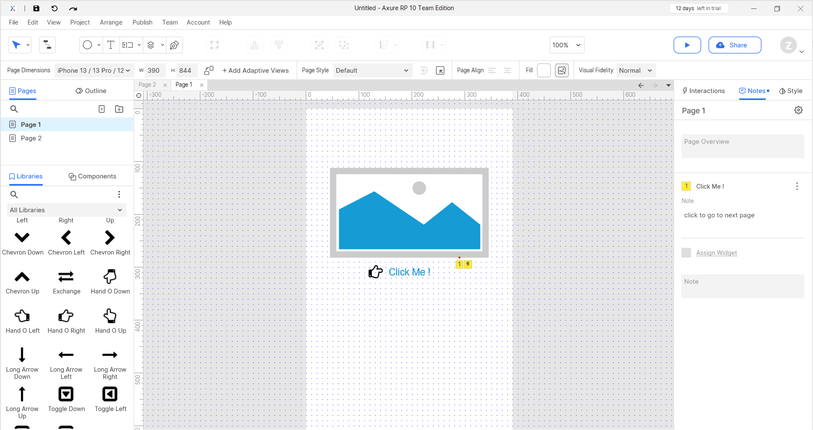

* Custom Page dimension to meet the page you are targeting for

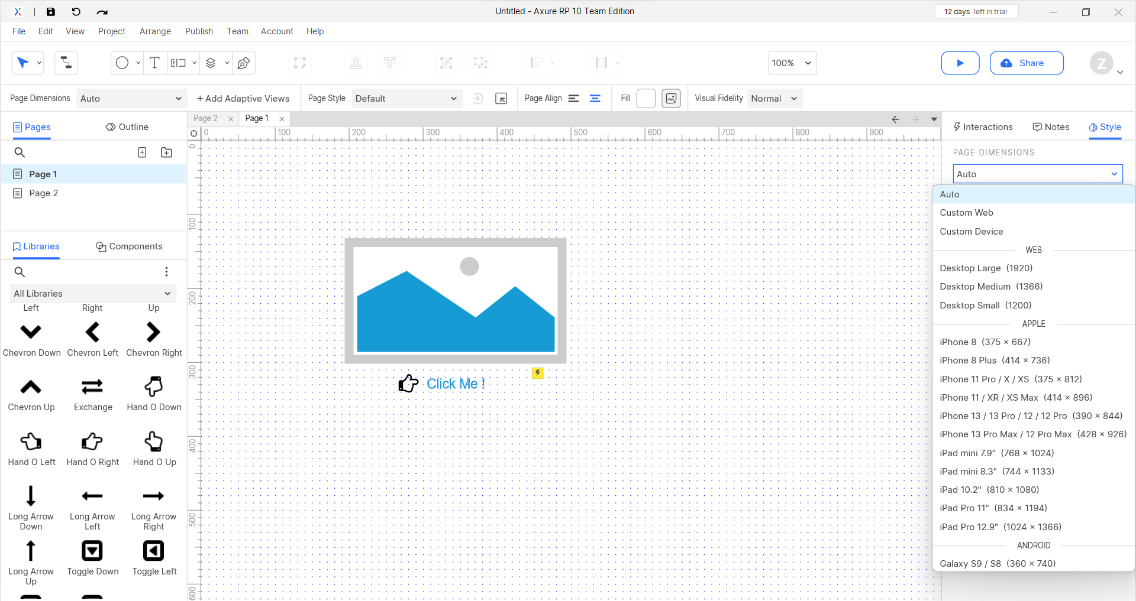

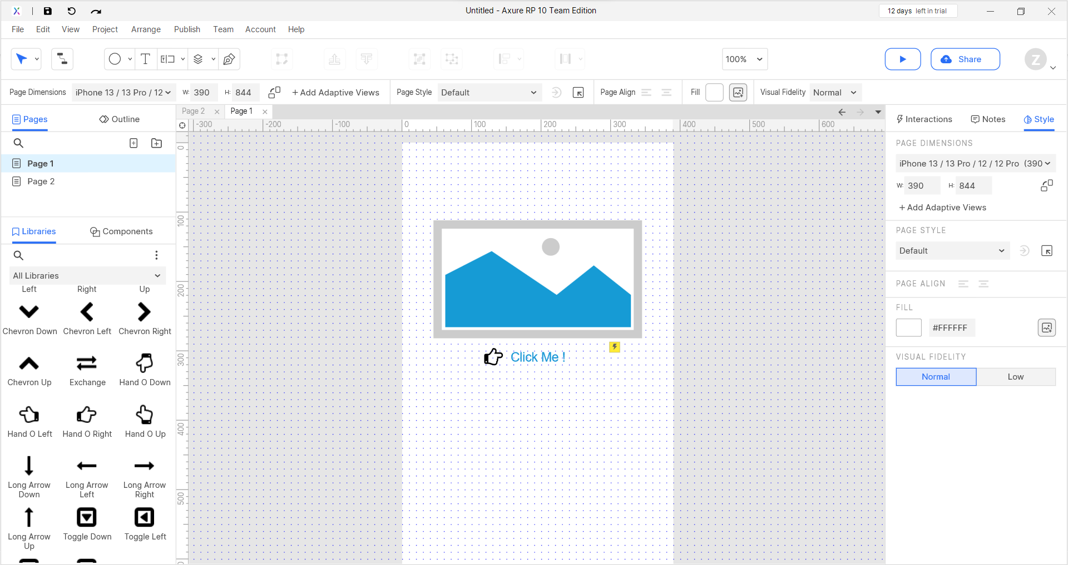

# Personas:

Table: Seller Personas

|  |  |  |  |  |  |  |
| --- | --- | --- | --- | --- | --- | --- |
| **Name** | **Demographics** | **Classification** | **Behavior** | **Beliefs** | **Characteristics** | **Goals** |
| Sophie | 23 years old Female | Entrepreneur | Curious, Ambitious | Believes in developing something of her own | Hardworking, likes taking risks | To launch her own business |
| Charles | 54 years old Male | Brand Manufacturer | Emphasizes product quality and dependability, and has a committed clientele | Believes in reputation and durability of the brand | Intelligent, forward-thinking, and centered on growing brand recognition | By smart collaborations and digital marketing, raise brand awareness and market share |

Table: Consumer Personas

|  |  |  |  |  |  |  |
| --- | --- | --- | --- | --- | --- | --- |
| **Name** | **Demographics** | **Classification** | **Behavior** | **Beliefs** | **Characteristics** | **Goals** |
| Ray | 30 years old Male, Professional | Technology Enthusiast | Inquisitive | Believes that purchasing should be convenient | Enjoys learning about new technology | To discover the ideal products at a reasonable cost |
| Wendy | 19 years old Non-binary | Budget Shopper | Focuses on essentials and restricts unnecessary spending | Wants convenience and reasonable prices | Minimalist lifestyle, concern for the environment, and social conscience | Buy things that satisfy their fundamental wants and are consistent with their principles |

For the Seller Personas, Sophie, and Charles, I consider using the Iterative Prototyping process. Iterative prototyping is a technique that enables designers to produce numerous prototypes with progressively higher levels of fidelity and usability. Rapid iteration and feedback are made possible by this strategy, allowing the user the chance to offer feedback and alter the design as necessary. They can test their ideas using this method rapidly and with little overhead, which is perfect for them. Additionally, it enables them to continue improving their design as they receive customer feedback.

Ray, Wendy, and the Consumer Personas should all be prototyped utilizing the Agile Prototyping technique, I say. Agile prototyping is a technique that stresses user and designer cooperation to produce a prototype that satisfies the user's needs. They can rapidly and effectively determine the greatest features and functions for their product thanks to this strategy, which is ideal for them. Additionally, it enables them to modify and improve the design in response to user feedback.

The following scenarios will be tested by the user:

As for the Seller Persona, Charles:

* He will try to sign up on the site.
* After logging in, he will try to see or change his seller profile.
* He will try to add items to her catalog in an effort to market his goods.

For the Consumer Persona, Wendy:

* She will try to sign up at the site.
* After logging in, she will want to access or update her user profile.
* She will try to conduct product searches.
* She will try to view the product details information.

# Prototyping Plan:

The steps of the Prototyping Plan are as follows:

1. Establish the Project's Parameters - Describe the end-demands user's and user requirements.
2. Examine the Requirements - Review the user specifications and make a list of the features and functionalities that must be incorporated into the prototype.
3. Design and Create the Prototype. Start with a wireframe and turn it into a functional prototype.
4. Test the Prototype - Try out the prototype and gather user feedback.
5. Refine the Prototype - Adjust the prototype in light of user feedback.
6. Finish the Prototype - Finish the prototype and get it ready to go.

Timeline:

Phase 1: Identify project objectives and goals, this takes about a week.

Phase 2: Determine the target market; this may take about one week.

Phase 3: User persona creation, may take at least a week.

Phase 4: Choose the best prototype approach; 3 or 4 days.

Phase 5: Develop a prototype in three weeks.

Phase 6: Test the prototype for two weeks.

Phase 7: Refine the design after analyzing criticism for one week.

Phase 8: Continue to refine prototypes.

Tools and Methodology:

* Step 1: Establish the project's objectives and goals. No particular tool or methodology is necessary.
* Step 2: Determine the target audience; there is no required methodology or tool.
* Step 3: Build user personas using tools like Persona.ly, persona creation technique.
* Step 4: Choose the best prototyping approach. Interactive prototyping is a methodology that can be employed, and tools like Sketch, Figma, Adobe XD, or Axure can be used.
* Step 5: Build a prototype - You can use tools like Sketch, Figma, Adobe XD, or Axure along with a chosen prototyping process.
* Step 6: Prototype testing can be done using platforms like UserTesting.com or Lookback as well as user testing methods.
* Step 7: Refine the design after considering input by using technologies like Google Analytics, or SurveyMonkey, as well as analysis techniques like qualitative and quantitative data analysis.
* Step 8: Prototyping should be iterated, using the chosen technique and tools continuously.

# Analyzing the impact of prototyping techniques on the software development lifecycle:

The software development lifecycle is significantly impacted by the adoption of prototyping approaches. It enables speedy iteration and feedback, enabling developers to immediately detect and take care of any potential problems. Furthermore, it enables a more user-centric design approach, enabling users to offer input and assist in molding the product to suit their needs. Third, it makes the development process more effective since developers can more rapidly spot potential improvement areas and implement improvements.

# Design and Development:

I'll be using Axure as my main tool to create several prototypes for this project. I can easily generate high-fidelity prototypes with Axure's user-friendly interface and variety of capabilities. It provides a variety of widgets and templates that enable me to easily construct multiple screens and user processes. Axure is a great option for this project because it also facilitates simple team communication.

I can quickly produce numerous prototypes using Axure for various scenarios, iterate on them based on user feedback, and make the necessary changes to enhance the user experience. I can test and improve prototypes with Axure by simulating user events like clicks, hovers, and scrolls before going on to the following iteration.

* I started by using Axure to create a wireframe of the interface in order to develop a high-fidelity prototype. To produce a realistic picture of the finished product, I later included specific design components like colors, photos, and text.
* I used interactive features like buttons, menus, and clickable links to make the prototype user-friendly and simple to use.
* I tested the prototype numerous times and made changes in response to user comments to make sure the functionality was correct. This made it easier for me to spot the prototype's flaws and make necessary adjustments to bring it up to project standards.
* I paid special attention to the details throughout the design process to produce a high-fidelity prototype that offered a true depiction of the finished product.

# Examining User Feedbacks:

I shared my Boutiqa website prototype with my classmates to get their opinions. After giving them a brief rundown of the website's objectives, features, and intended users, I gave them the opportunity to explore the prototype on their own. They were asked to comment on the general look, structure, and user experience.

I took their feedback, carefully reviewed it, and made note of any areas that needed improvement. The most often stated issues included ambiguous branding, unclear product descriptions, and imprecise navigation. In response to these concerns, I improved the prototype's product descriptions.

Prototype 1

Feedback 1:

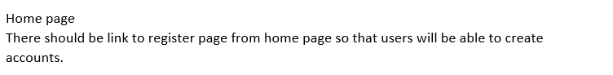

Modification 1: Added a Registry that is linked to the register page in the nav bar for better user experience.

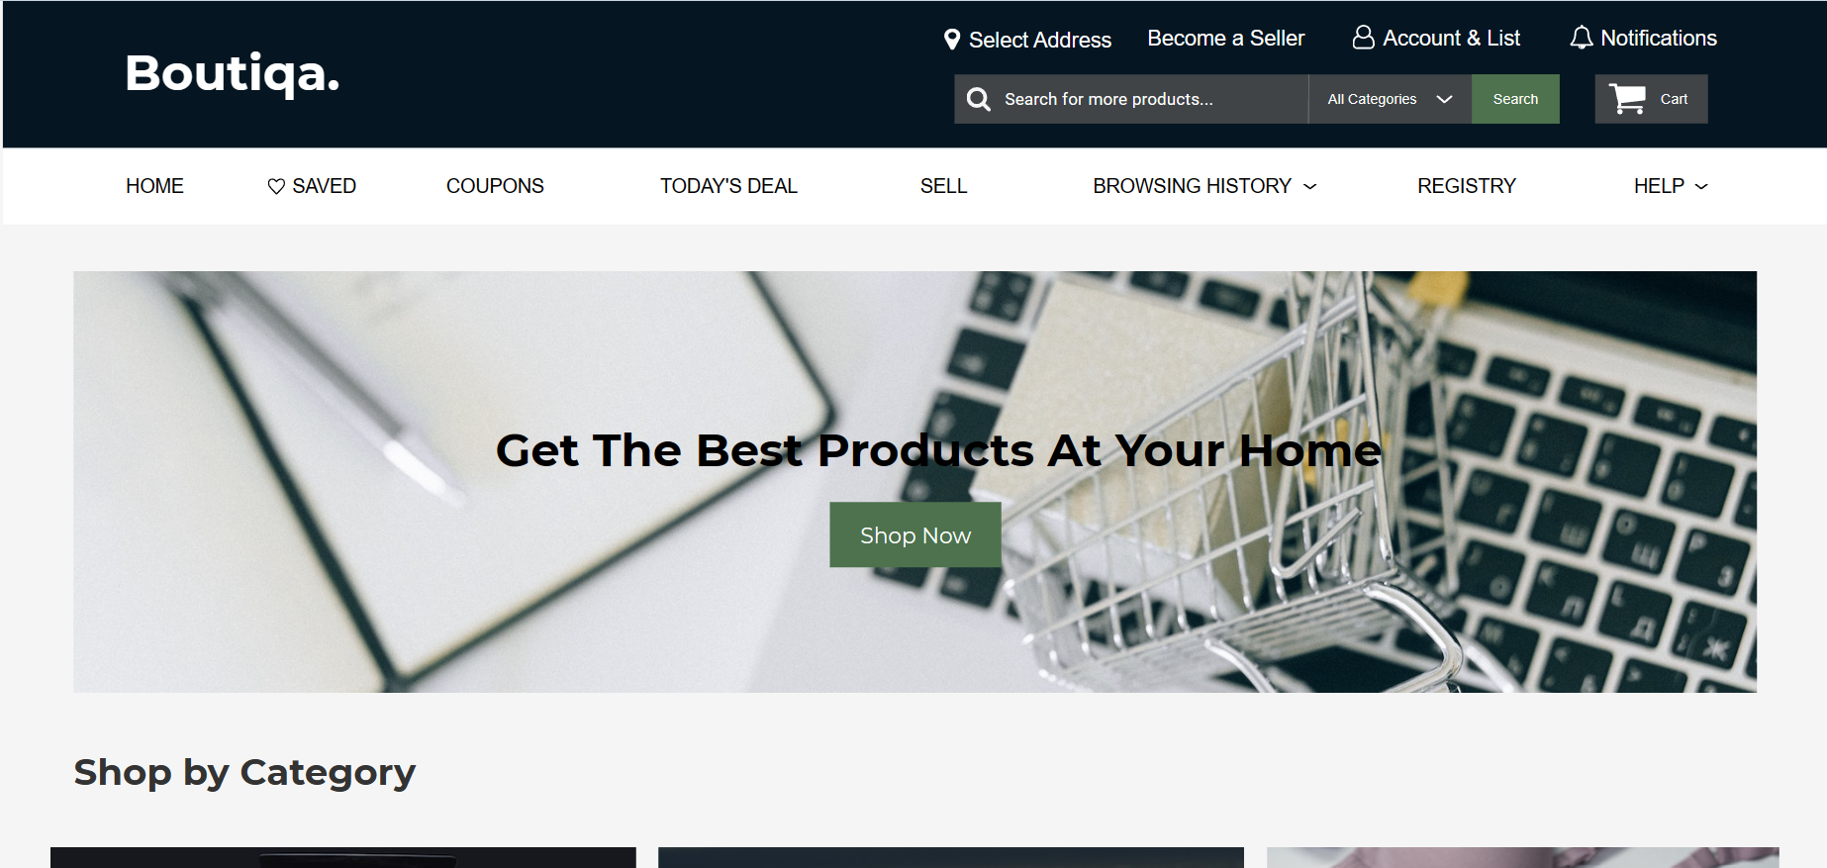

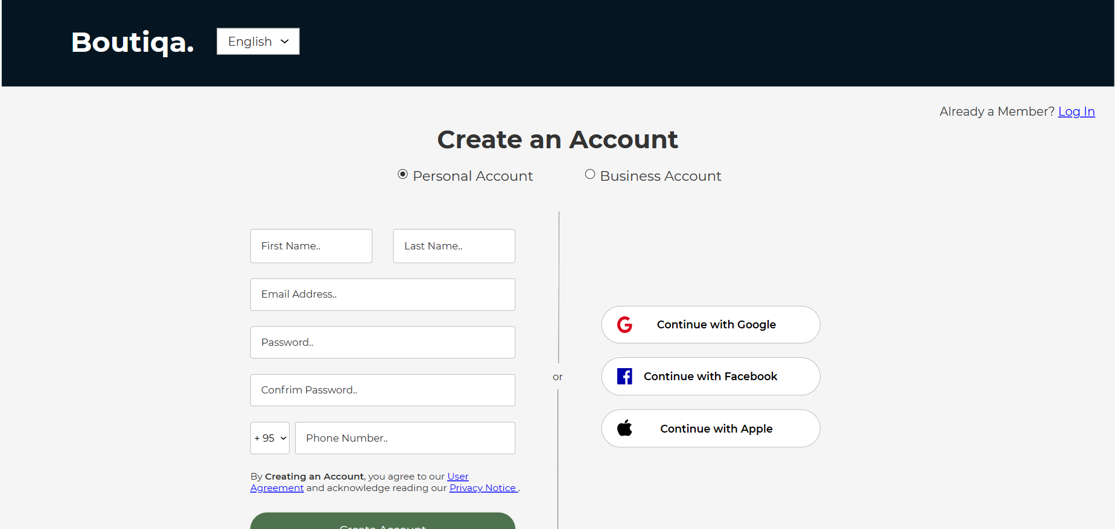

Feedback 2:



Modification 2: Added the product to the home page where it is visible and if the visitors can click on it to view in detail.

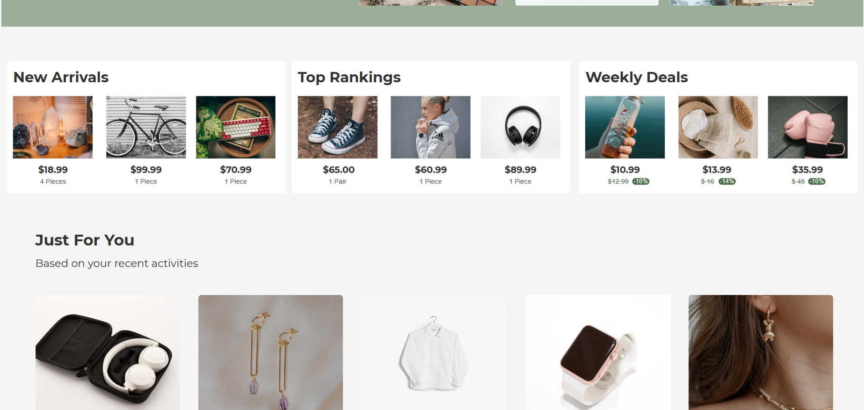

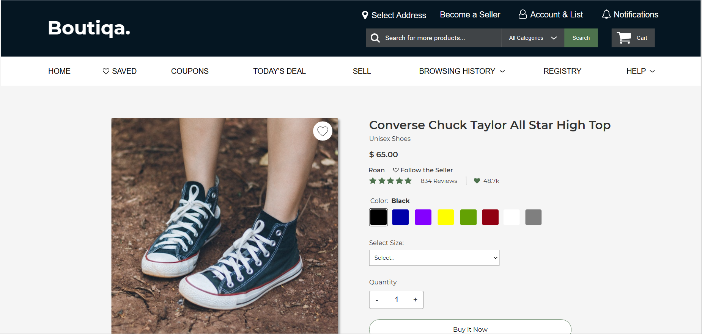

Feedback 3:

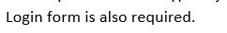

Modification 3: Added a login page where the customers can easily log back into their accounts.

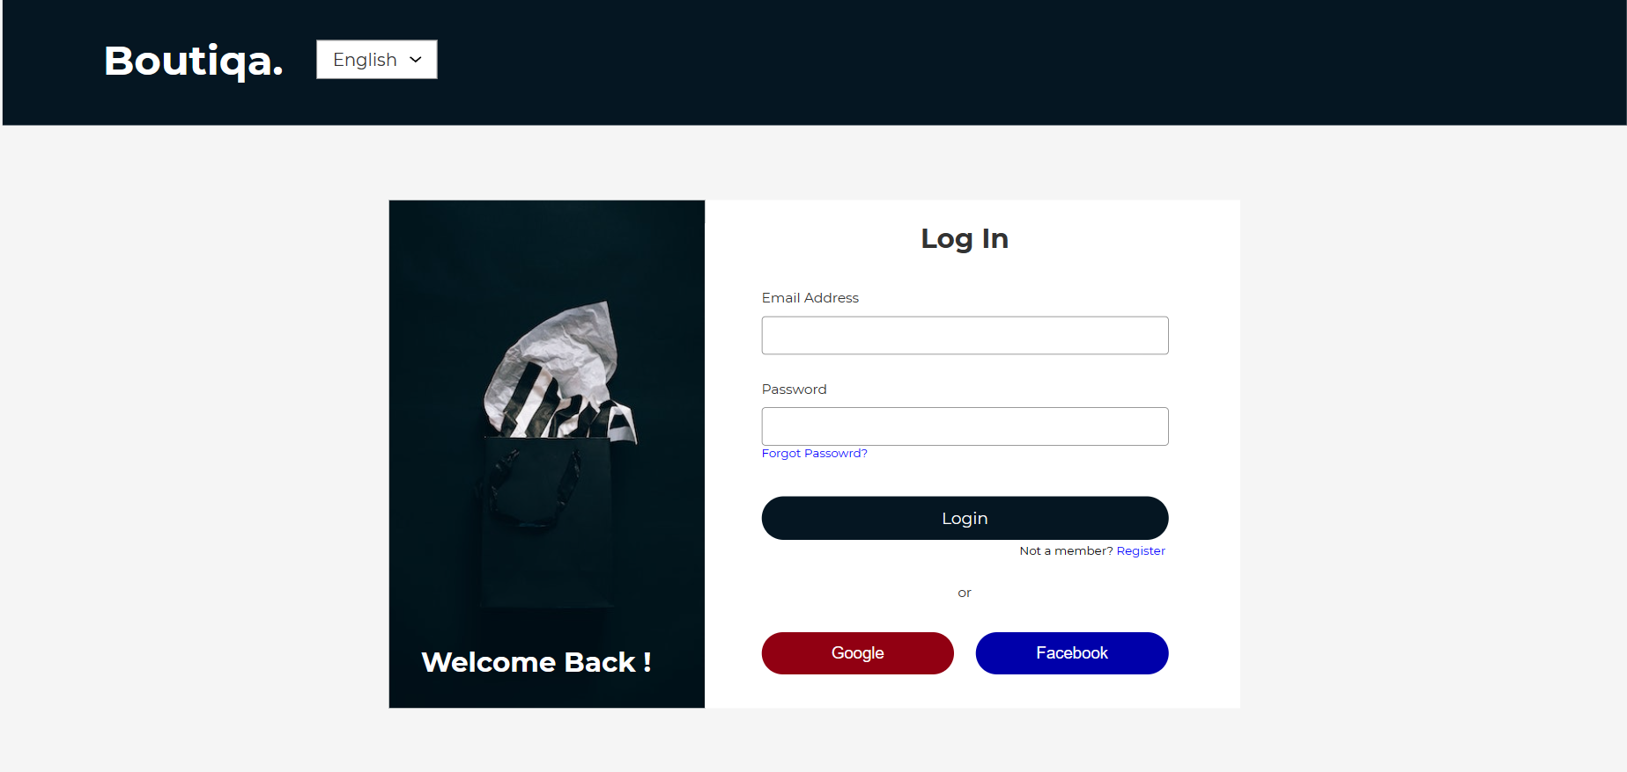

Feedback 4:



Modification 4: I also did an update on that comment where the pages are linked, you can see that when you test run the prototype.

Feedback 5:



Modification 5: Created a Login/ Register Successfully Page.

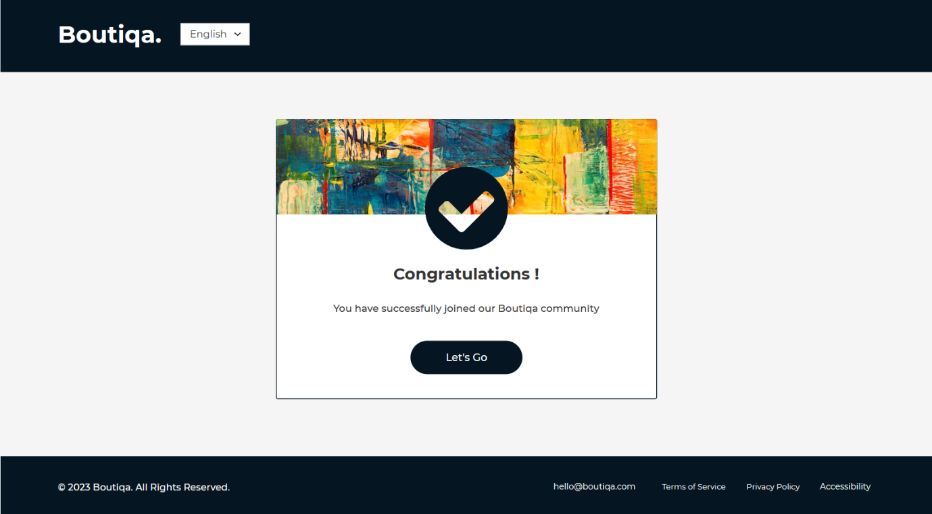

This is the final outcome after all the improvements. Based on the most pertinent user comments, improve the prototype.

Prototype 2

*Landing Page:*

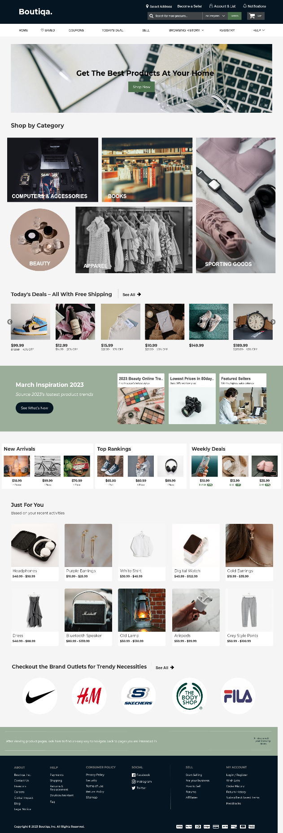

*Seller Profile Page:*

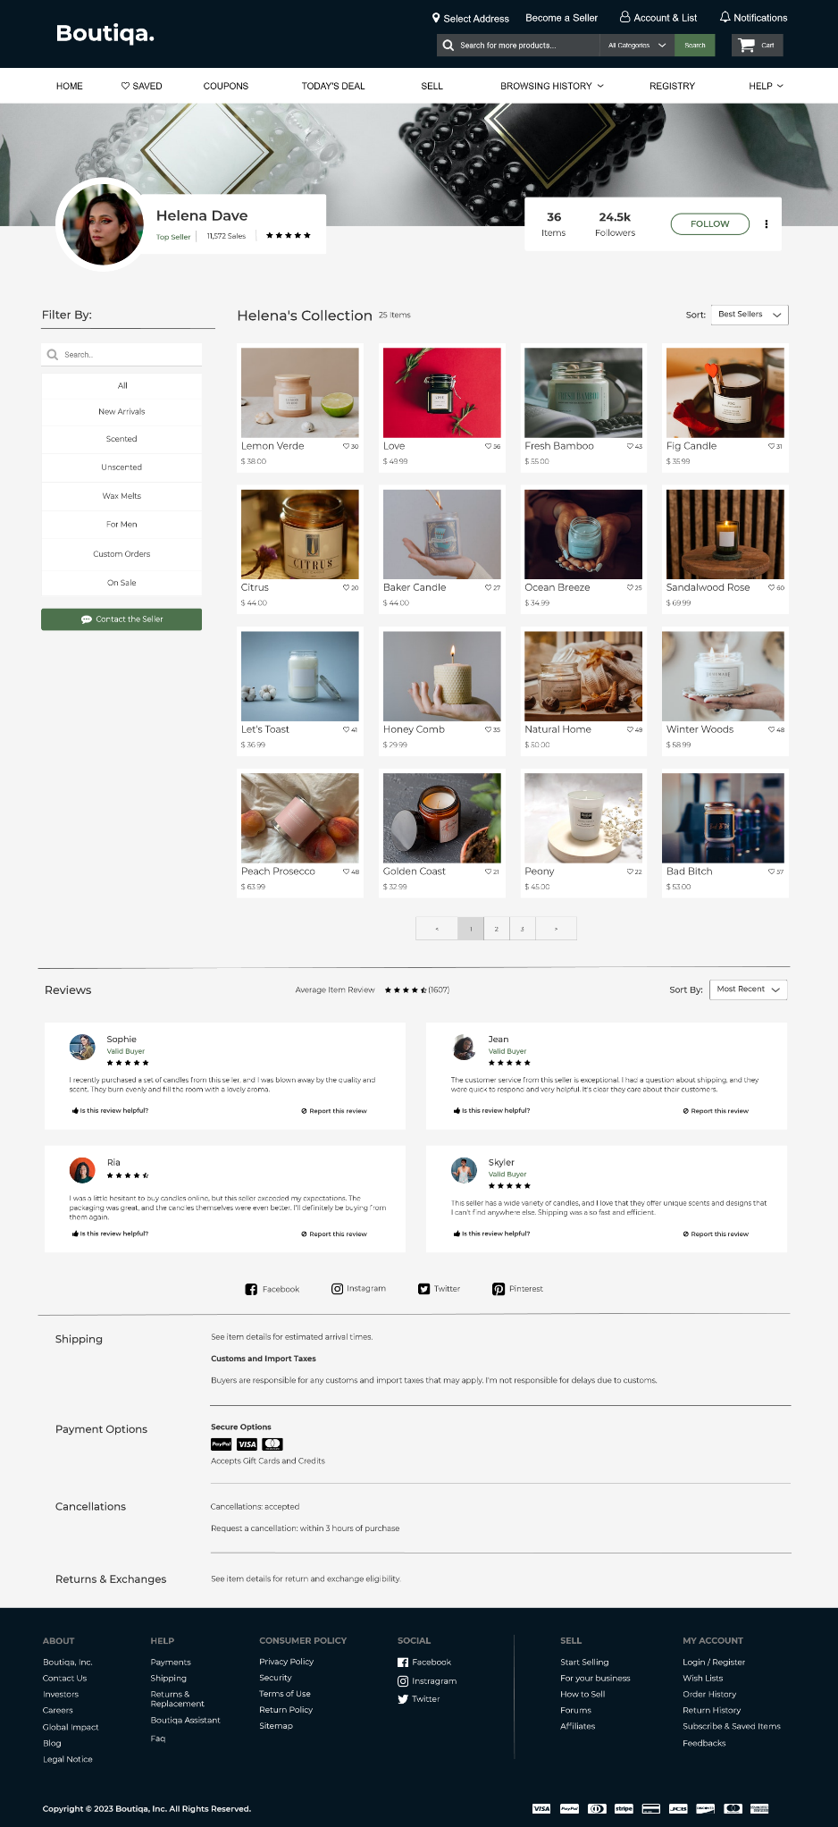

*Edit/ Update Seller Profile Page:*

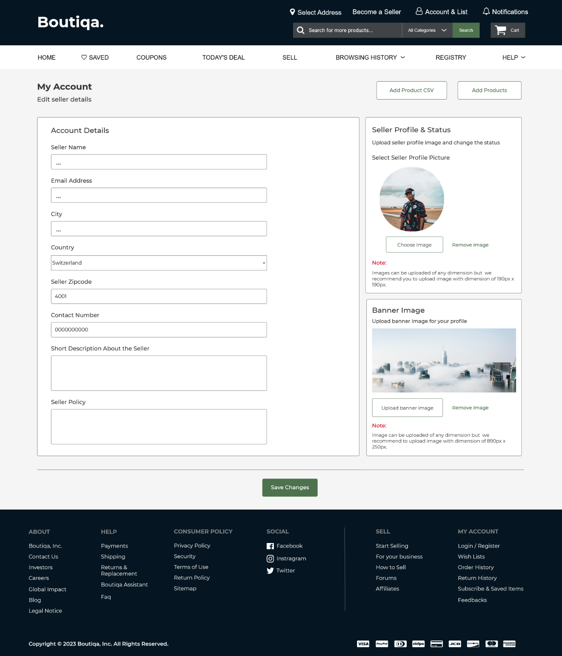

*Consumer Profile Page:*

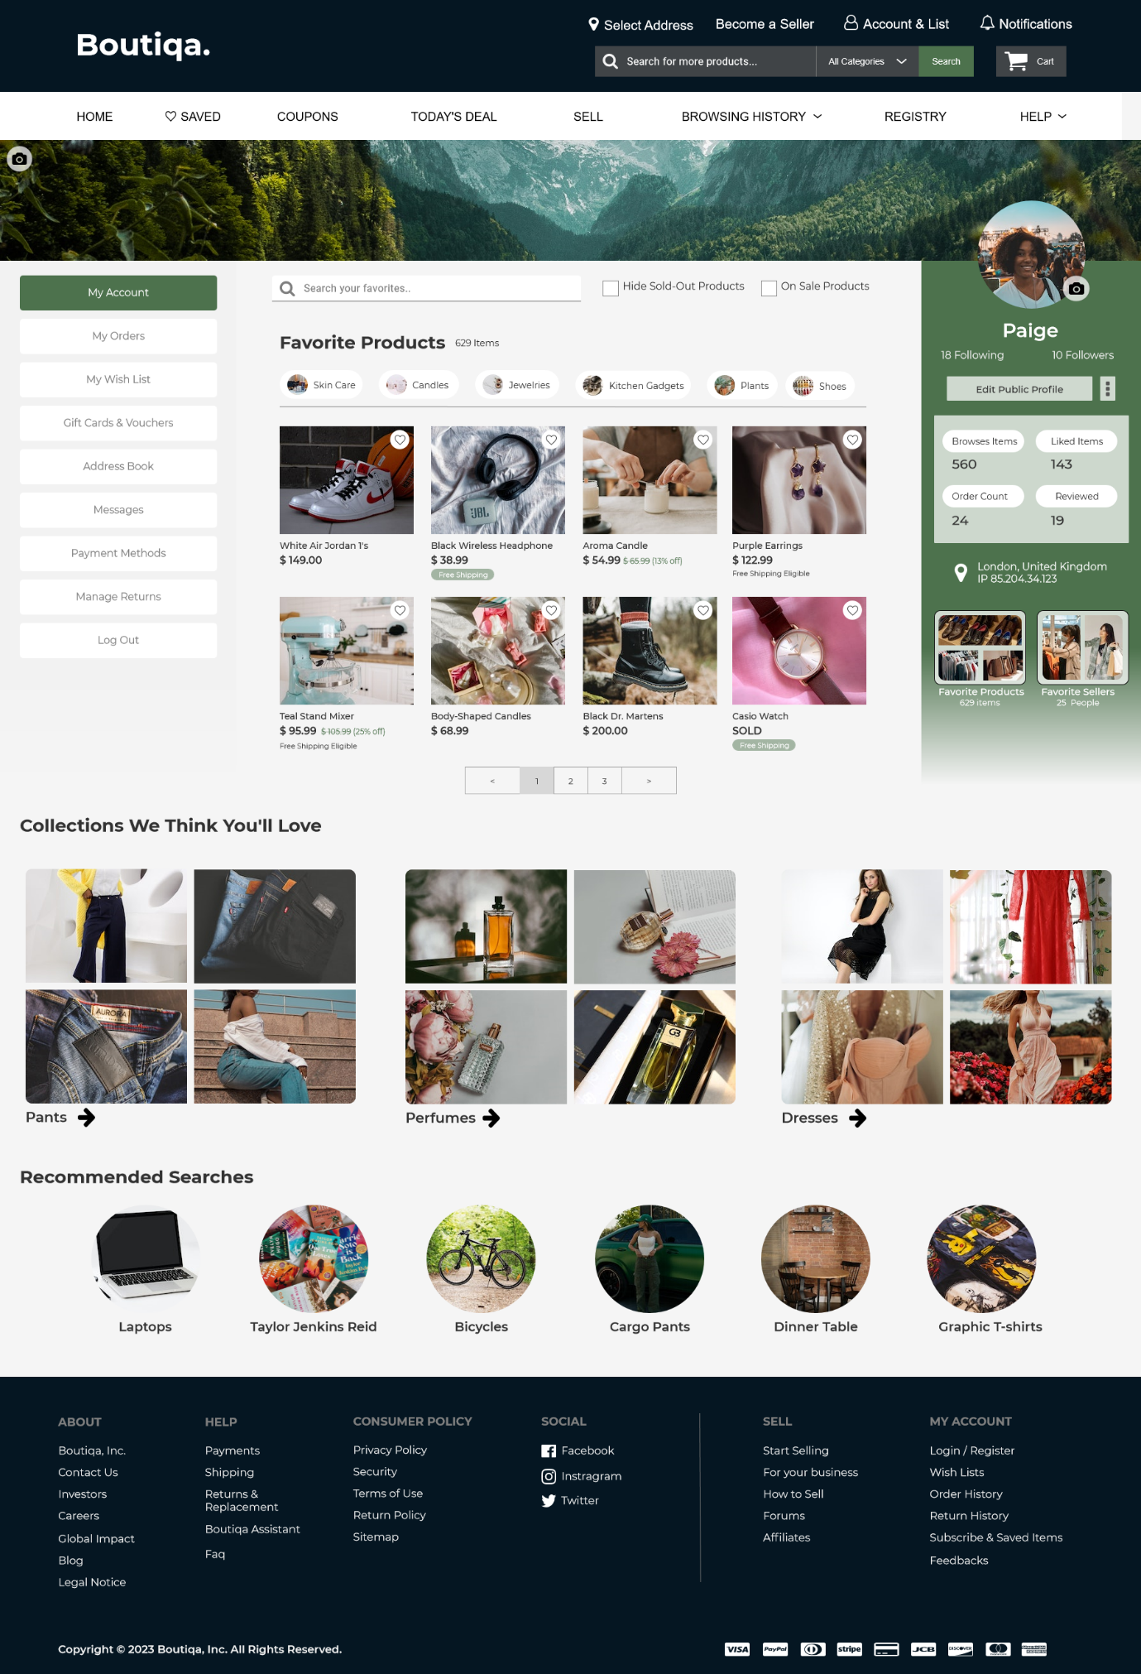

*Edit/ Update Consumer Profile Page:*

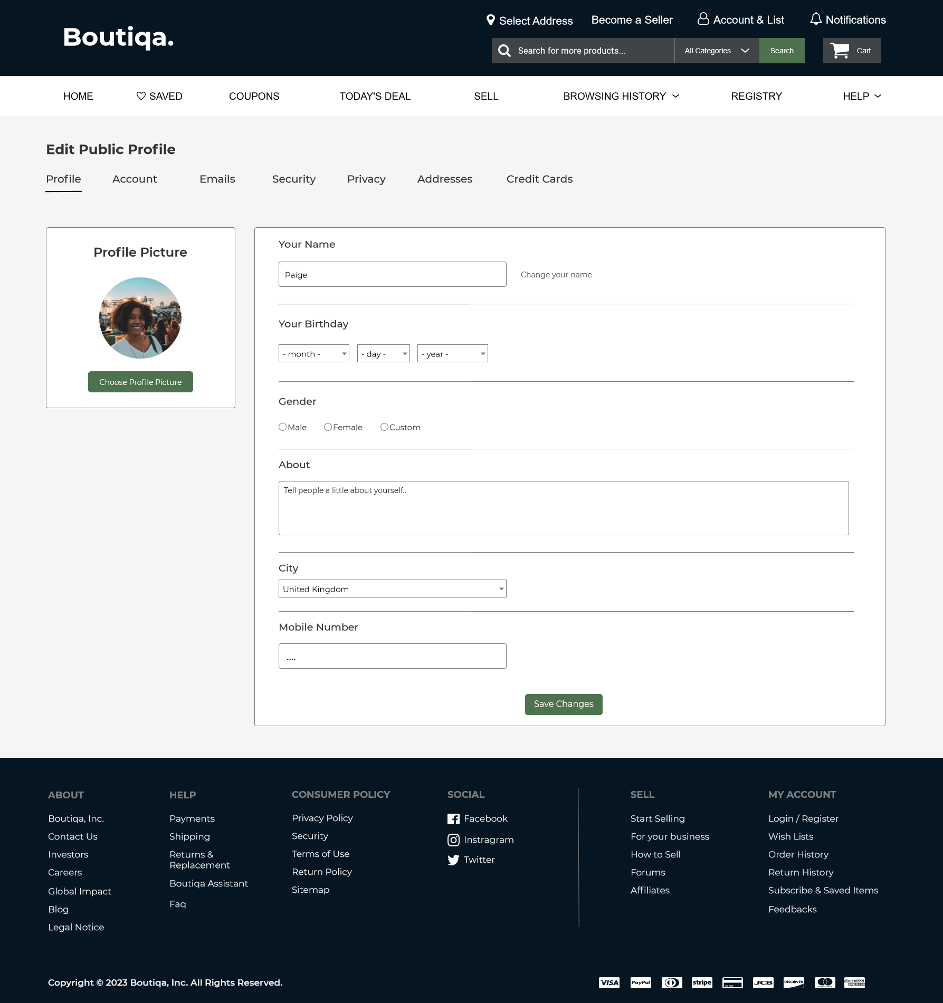

*Register Page (Personal Account):*

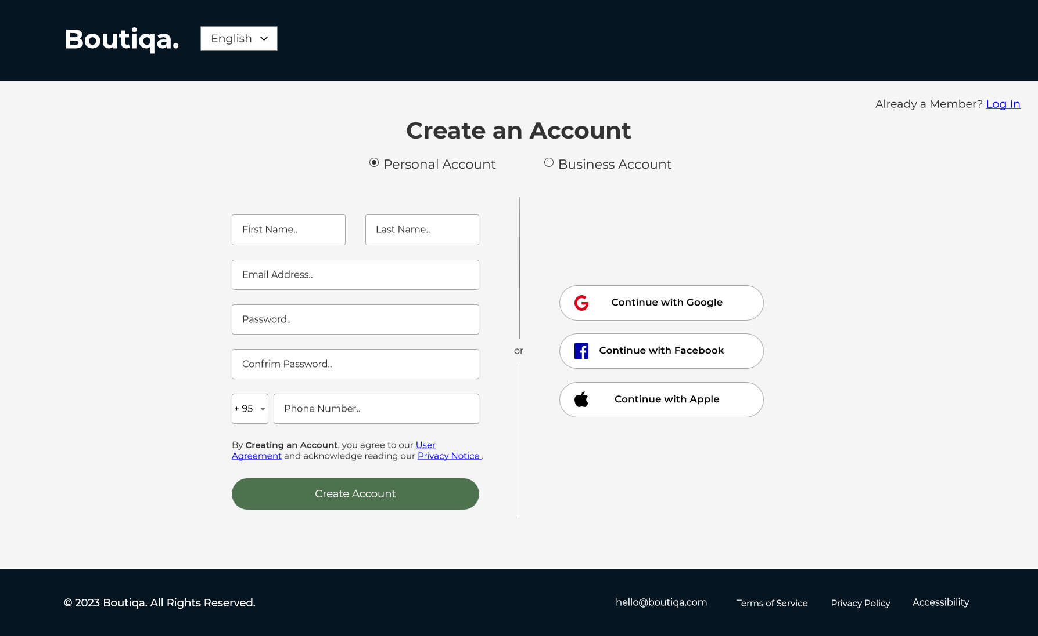

*Register Page (Business Account):*

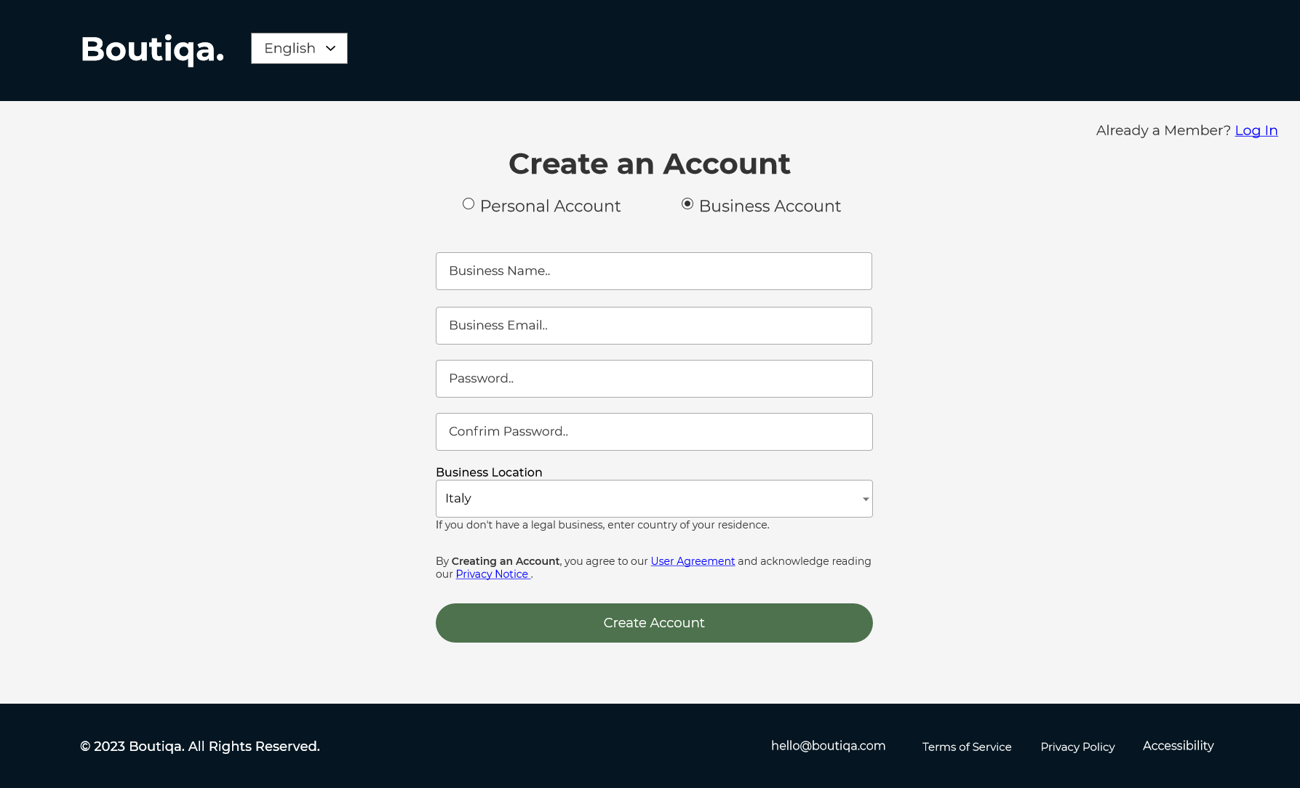

*Login Page:*

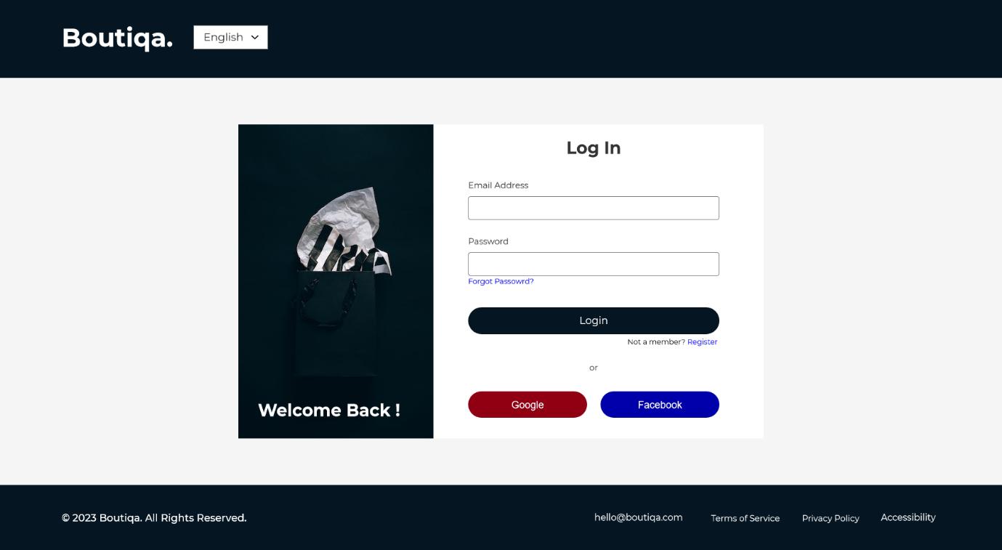

*Register Successful Page:*

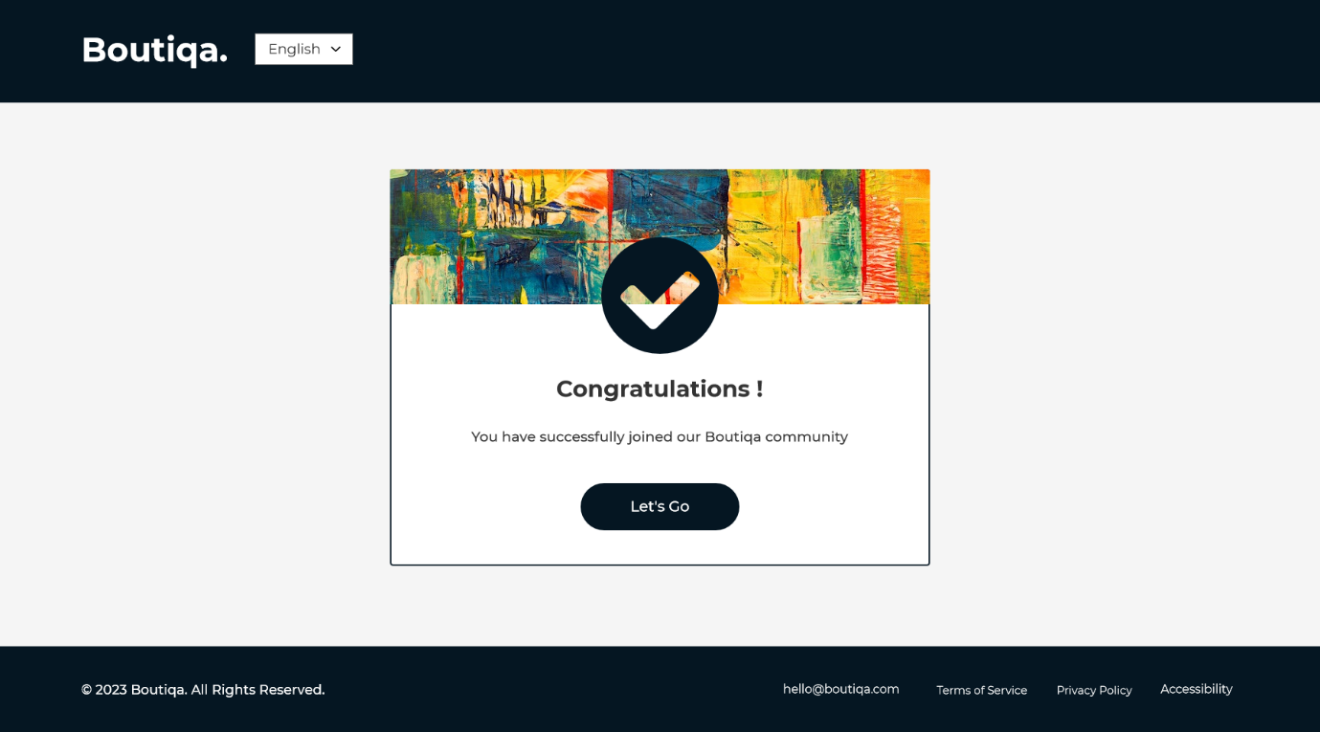

# UX KPI Calculations of the Boutiqa Prototype:

1. Conversion Rate

|  |  |
| --- | --- |
| Metric | Value |
| Number of visitors | 30,000 |
| Amount of conversions | 900 |

Conversion Rate = (Amount of conversions / Number of visitors) * 100

Conversion Rate = (900 / 30,000) * 100 = 3%

1. Test Success Rate

|  |  |  |  |
| --- | --- | --- | --- |
| Task | Total Attempts | Successful Attempts | Task Success Rate |
| Sign up on the Portal | 100 | 95 | 95% |
| Adding to Cart | 60 | 53 | 88% |
| Checking Out | 33 | 30 | 90% |
| Update Profile | 50 | 40 | 80% |

1. Time on Task (In minutes)

|  |  |  |
| --- | --- | --- |
| Task | Avg, Time on Task | Total Task Attempts |
| Register in the portal | 2 minutes | 250 |
| Update profile | 1.5 minutes | 100 |
| Search products | 1 minutes | 130 |
| View product details | 0.75 minutes | 90 |
| Adding to cart | 1.25 minutes | 45 |
| Checking out | 2.2 minutes | 78 |
| Maintain product catalogue | 3 minutes | 165 |

1. User Error Rate

|  |  |  |
| --- | --- | --- |
| Task | Total Errors | Error Rate |
| Register in the portal | 10 | 25% |
| Adding to cart | 8 | 20% |
| Update profile | 6 | 10% |
| Search products | 5 | 9% |
| Checking Out | 6 | 10% |

1. System Usability Scale Score (SUS)

|  |  |
| --- | --- |
| User | SUS Score |
| 1 | 90 |
| 2 | 85 |
| 3 | 70 |
| 8 | 77 |
| … | … |

Average SUS Score: (90 + 85 + 70 + 77 + ...) / 20 = 75

1. User Satisfaction

|  |  |
| --- | --- |
| User Rating | Number of Uses |
| 4 out of 5 | 50 |
| 5 out of 5 | 75 |
| 4.5 out of 5 | 40 |
| 2 out of 5 | 20 |

1. Net Promoter Score (NPS)

We can calculate the NPS assuming we have gathered feedback from 50 users.

|  |  |
| --- | --- |
| User | NPS Response |
| 1 | 9 |
| 2 | 7 |
| … | … |
| 40 | 10 |

Promoters (9-10): 20

Passives (7-8): 15

Detractors (0-6): 15

NPS = (Promoters - Detractors) / Total Responses * 100 = 19

# Evaluation of Test Results

|  |  |  |  |  |  |
| --- | --- | --- | --- | --- | --- |
| Iteration | User Feedback | Identified Issues | Priority | Design Updates | Testing Results |
| Iteration 1 | The registration procedure was difficult and time-consuming for sellers. | Complicated registration procedure for sellers. | High | Simplified registration for sellers. | Enhanced completion rate for registration. |
| Iteration 2 | Buyers found it challenging to update their profiles. | Problems with profile updates for visitors. | High | For consumers, improved profile update flow. | Higher success rate for profile updates. |
| Iteration 3 | Large product catalogs were reportedly challenging for sellers to manage. | For sellers, product catalog management has to be improved. | High | Added tools for mass editing and filtering product catalogs from sellers. | Sellers can manage their product catalogs more easily. |
| Iteration 4 | Customers asked for more thorough product information. | Consumers are not given enough product information. | High | Included a consumer-friendly area with expanding product descriptions. | Improved customer access to product information. |
| Iteration 5 | While expressing satisfaction with the overall user experience, sellers and customers asked for modest usability improvements. | Minor UI polishing and usability enhancements. | Low | UI components and interactions have been improved based on user feedback. | Positive comments on the enhanced usability and polished UI from both sellers and customers. |
| Iteration 6 | Order tracking and processing problems were mentioned by the sellers. | Problems with order processing and tracking for sellers. | Medium | Enhanced tools for vendors to manage orders. | Simplified order processing and tracking for sellers. |
| Iteration 7 | Customers wanted a customized recommendation. | Lack of customer-specific recommendations. | Medium | Engine for customized suggestions has been implemented. | Product recommendations are more specific to consumers. |

# New Iteration Indicating

* Enhance the Search Functionality - Some users complained that the search was difficult to use and inaccurate. To enhance the user experience, think about incorporating filters and improving the search algorithm.
* Improve the Product Pages - A few people said the product pages might be enhanced to include better product photos and more in-depth information. Think about enhancing your content with additional pictures, in-depth descriptions, user reviews, and ratings.
* Enhance the Mobile Experience: - Some users complained that the mobile experience was a little slow and unresponsive. Consider making the website more mobile-friendly, including by enhancing the layout and appearance for smaller screens.
* Simplify the Checkout Process - Enhance user experience by streamlining the checkout process, which some customers found to be a little challenging. Consider streamlining the procedures and lowering the quantity of clicks necessary to finish a transaction.

Several prototypes were created and tested with end users while the Boutiqa website project was being developed. The feedback from each iteration was used to modify each prototype.

End-user offered feedback on the website's design, navigation, product descriptions, and editing of user profiles, among other elements. The checkout procedure was made simpler, there were more product photos added, and the search feature was enhanced as a result of customer input on the prototype.

End-user testing and feedback had a big influence on how the prototype was improved. The comments offered insightful information on how users engaged with the website and suggested changes that might be made to improve their experience. The final prototype was easier to use and more logical than the first one by taking these suggestions into account during each iteration.

The final prototype was created, and then it was evaluated for efficacy by end users. The test findings revealed that consumers considered the website to be simple to use and were able to complete transactions without any problems. The finished product also accomplished the project's original intentions and objectives.